**Functional Requirement Specification**

**Motor**

**Rules & Rating Engine**

For

**TIGB – GTSR Phase 2**

Version No.1.1

Date: 04-Jul-2023

**Functional Requirement Specification**

**Motor**

**Rules & Rating Engine**

Date: 31-May-2023

Table of Contents

1 Introduction 6

1.1 Purpose of Document 6

1.2 Scope of Change 6

1.2.1 Applicability 6

1.2.2 Extra Coverages Maintenance in Rules and Rating Engine 8

1.2.3 Make and Model maintenance in Rules and Rating Engine 8

1.2.4 Agent Group Maintenance 9

1.2.5 Risk Criteria Maintenance 9

1.2.6 Vehicle Type Code Maintenance 10

1.2.7 Pricing Data Maintenance 10

1.2.8 Pricing / Rule Serial Number 17

1.2.9 Request and Response from Rules and Rating Engine 23

1.2.10 Contribution Calculation 23

1.2.11 Pricing Serial Number Transactions 31

1.2.12 Storage in the Rules and Rating Engine 33

1.2.13 Audit Log 33

1.2.14 Rules and Rating Engine Sample Screens 33

1.2.15 Functions available in Rules and Rating Engine. 35

1.2.16 Business process Flow 37

1.3 Definition of Terminologies Used 37

2 Appendix 37

**DOCUMENT SIGN-OFF**

|  |  |  |  |  |  |
| --- | --- | --- | --- | --- | --- |
| **Name** | **Position** | **Role (Reviewer/Approver)** | **Comments** | **Signature** | **Date** |
|  |  |  |  |  |  |
|  |  |  |  |  |  |
|  |  |  |  |  |  |
|  |  |  |  |  |  |
|  |  |  |  |  |  |
|  |  |  |  |  |  |
|  |  |  |  |  |  |
|  |  |  |  |  |  |

**DOCUMENT CHANGE HISTORY**

|  |  |  |  |
| --- | --- | --- | --- |
| **Document Version** | **Author(s)** | **Change Reference** | **Date** |
| 0.1 | C.Sampathkumar | Initial Version | 16-Jun-2023 |
| 1.0 | C.Sampathkumar | Based on the Comments from Amin and Amirul updated the FRS.  *The below sections are added / updated*  *1.2.2. Extra Coverage applicable Criteria added*  *1.2.10.k. Sample Contribution Calculation – Minimum Premium*  *In Section 1.2.8.a - Agreed Value Clause added*  *1.2.14 Rules and Rating Engine Screen Design*  *1.2.15 Functions available in Rules and Rating Engine*  *Under Section 1.2.10.c.Extra Coverage Contribution section e-Hailing Endorsement handling added* | 30-Jun-2023 |
| 1.1 | C.Sampathkumar | **Comments from Amin:**  1.2.7.a. Pricing Factors – Updated with 5 Additional Factors  1.2.7.g Extra Coverage Rate and Formulas  *Extra Coverage Contribution shall also be calculated in the Rules and Rating Engine for both Tariff Products and De-Tariff Products*  1.2.8 Pricing / Rule Serial Number – added a statement as below:  *Pricing Serial number format can changed later, with Technical assistance*  1.2.10.c. Extra Coverage Contribution  *Updated as PRIVATE HIRE CAR ENDORSEMENT (E-Hailing Endorsement) Contribution shall be calculated in the Rules and Rating Engine for Full Year and non-annual.*  **Comments from Hamsiah:**  Section 1.2.8.b. Extra Coverage Contribution  *Screen shots of the e-mail was removed and a Table added*  Section 1.2.6 Vehicle Type Code Maintenance. The below statement updated.  *An Interface will be available for the user to add new Vehicle Types in future*  Section 1.2.8.e. Rule Serial Number  *Typo error "from end" changed as "front end"* | 04-Jul-2023 |
|  |  |  |  |
|  |  |  |  |
|  |  |  |  |
|  |  |  |  |

# Introduction

As per the new system, the Rules, Pricing and Contribution calculation shall be maintained Rules and Rating Engine. All the Applications like FLAS, GoApps, Merimen, PREMIA etc., to issue Motor and Non-Motor Quotation / Cover Note shall sent a request to Rules and Rating Engine for Rules, Pricing and Contribution calculation. When there is a change in Rules / Pricing, the required changes will be done in the Rules and Rating Engine only and the same will be effected in all other Applications (Front End)

## Purpose of Document

The purpose of this document is to explain how the Rules and Rating related data shall be maintained in the Rules and Rating Engine to compute the Contribution for different Vehicle Types and share the Contribution to Front End Systems.

## Scope of Change

This Change Request shall cover the following.

### Applicability

#### Applicable Vehicle Types

In this phase, for the following Vehicle Types the Contribution Computation shall be maintained in the Rules and Rating Engine.

1. Private Car
2. Private Car Comprehensive Plus
3. Motor Cycle
4. Commercial Vehicle

An Interface will be available for the user can add new Vehicle Types in future

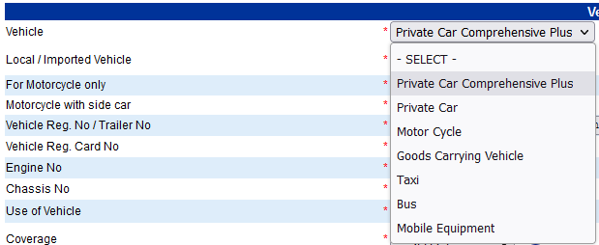

#### Applicable Coverage Type

Based on the Vehicle Type the following Coverages are applicable and the Contribution Calculation for the same shall be maintained in the Rules and Rating Engine

An Interface will be available for the user can add new Coverage Types in future

|  |  |  |  |
| --- | --- | --- | --- |
| Sl. No. | Vehicle Type | Coverage Type | De-Tariff Contribution or Tariff Contribution? |
| 1 | Private Car Comprehensive Plus | Comprehensive | De-Tariff Contribution |
| 2 | Private Car | Comprehensive | De-Tariff Contribution |
| 3 | Private Car | TPFT | De-Tariff Contribution |
| 4 | Private Car | Third Party | Tariff Contribution |
| 5 | Motor Cycle | Comprehensive | De-Tariff Contribution |
| 6 | Motor Cycle | TPFT | De-Tariff Contribution |
| 7 | Motor Cycle | Third Party | Tariff Contribution |
| 8 | Goods Carrying Vehicle | Comprehensive | Tariff Contribution |
| 9 | Goods Carrying Vehicle | TPFT | Tariff Contribution |
| 10 | Goods Carrying Vehicle | Third Party | Tariff Contribution |
| 11 | Taxi | Comprehensive | Tariff Contribution |
| 12 | Taxi | TPFT | Tariff Contribution |
| 13 | Taxi | Third Party | Tariff Contribution |
| 14 | Bus | Comprehensive | Tariff Contribution |
| 15 | Bus | TPFT | Tariff Contribution |
| 16 | Bus | Third Party | Tariff Contribution |
| 17 | Mobile Equipment | Comprehensive | Tariff Contribution |
| 18 | Mobile Equipment | TPFT | Tariff Contribution |
| 19 | Mobile Equipment | Third Party | Tariff Contribution |

For Private Car and Motor Cycle the De-Tariff Contribution for Comprehensive and TPFT Coverage shall be calculated in the Rules and Rating Engine as per the GLM Sheet and the calculated De-Tariff Contribution shall be sent in the Response Service to the Front End System.

For Private Car and Motor Cycle the Tariff Contribution for Third Party Coverage also shall be calculated in the Rules and Rating Engine as per the GLM Sheet and the calculated Tariff Contribution shall be sent in the Response Service to the Front End System.

For Commercial Vehicles, Tariff Contribution for Comprehensive, TPFT and Third Party shall be calculated in the Rules and Rating Engine and the Tariff Contribution shall be sent in the Response Service to the Front End System.

In future for Commercial Vehicle user can compute the De-Tariff Contribution.

### Extra Coverages Maintenance in Rules and Rating Engine

* List of Extra Coverages by Vehicle Type, Vehicle Usage and Coverage Type shall be maintained in the Rules and Rating Engine
* The Rules and Rating Engine shall have an option to Upload with xls, xlsx, xlsm file format, to add / update the Extra Coverages
* User can add new extra Coverages / edit the existing Extra Coverages.
* The Rules and Rating Engine shall have an option to download the Extra Coverages available in the Rules and Rating Engine, in Excel format
* While issue a Quotation / Cover Note, when there is a request from the Front End System, the Rules and Rating Engine will share the applicable Extra Coverages along with the Rate, based on the Vehicle Type, Vehicle Usage and Coverage Type received in the Request Service
* A separate Web Service (API) – Extra Coverage Service will be available to share the applicable Extra Coverages with front end System
* Refer the attached excel file for Master List of Coverages. Sheet Name: AdditlBenTagtoSubClass and SubClassCode
* All the Systems connecting to Rules and Rating Engine, (FLAS, Premia, GoApps etc.,) shall pass the “SUBCLASSCODE” as mentioned in the worksheet - “SubClassCode” from the above referred excel file.
* The Extra Benefits are applicable based on the Agent Pricing Group Code, Vehicle Make, Age of Vehicle and Coverage. Sum Covered, Participant's Age (Insured Person’s Age) , Vehicle Usage, and State shall added as additional criteria for Extra Benefits.
* Based on the SUBCLASSCODE received, the Rules and Rating Engine shall return Extra Coverages applicable for the requested Agent group / Product etc.,
* For the Extra Coverages Motorist PA and Bantuan Ikhlas Supreme Service Tax and Stamp Duty shall be calculated separately. An indicator shall be available in the Extra Coverage Master Data to identify the extra coverage for which Separate Stamp Duty and Service Tax shall be calculated.
* Cover Note generation will happen at the front end system. Rules and Rating Engine will send two separate premium to the front end system, one is for motor and the other one is for MPA cross selling product with respective Service Tax and Stamp Duty
* An Interface shall be available in the Rules and Rating Engine to add / edit the Extra Coverages

### Make and Model maintenance in Rules and Rating Engine

* List of Make, Model and Segment shall be maintained in the Rules and Rating Engine
* An Interface shall be available in the Rules and Rating Engine to update the Make, Model and Segment.
* The Rules and Rating Engine shall have an option to upload with xls, xlsx, xlsm file format, to add / update the Make, Model and Segment.
* The Rules and Rating Engine shall have an option to download the Make, Model and Segment in Excel format
* Whenever there is any addition / change in the Make, Model and Segment, the Rules and Rating Engine shall sent the changes to the applicable Systems through a Web Service / API
* A separate Web Service – Make Model Service shall be available to send the Make, Model and Segment details to the applicable System
* Make, Model and Segment will be maintained as per the below table. In the Make and Model.



### Agent Group Maintenance

* An Agent will be mapped to two different Groups and these mapping shall be maintained in the Rules and Rating Engine.

1. Agent Rules Group
2. Agent Pricing Group

#### Agent Rules Group

* When an agent sent a request for Contribution, as a first step, the system shall get the applicable Agent Rules Group related to the agent, to fetch the applicable Rule. From the selected Rule, the system shall get the applicable Risk Type and Loading %
* Refer the attached Excel for Agent – Agent Rules Group Mapping

#### Agent Pricing Group

* As a second step, the System shall fetch the applicable Pricing Group related to the agent to fetch the applicable Pricing Serial Number. Based on the selected Rule and Pricing Serial Number the system shall compute the Contribution
* Refer the attached Excel for Agent – Agent Pricing Group Mapping

### Risk Criteria Maintenance

* All the Motor related Risk Criteria shall be maintained in the Rules and Rating Engine
* Based on the Agent Rules Group, the Risk Criteria will be maintained
* While the Front End System issue a Quotation / Cover Note, when there is a request to Rules and Rating Engine to get the applicable Risk Type, the Rules and Rating Engine will share the applicable Risk based on the criteria received in the Request Service.
* In the Response Service the Rules and Rating Engine will send the Risk Type (Accept / Refer / Decline) and based on this Response the Front End System will allow the user to generate the Cover Note or Refer to UW for Approval
* A separate Web Service - Risk Criteria Service API will be available to share the applicable Risk to front end System

### Vehicle Type Code Maintenance

|  |  |
| --- | --- |
| **VEHTYPECODE** | **VEHTYPEDESC** |
| PRCAR | PRIVATE CAR |
| PCPLS | PRIVATE CAR COMPREHENSIVE PLUS |
| MTCYC | MOTOR CYCLE |
| GCVEH | GOODS CARRYING VEHICLE |
| MOLBE | MOBILE EQUIPMENT |
| BUS | Bus |
| TAXI | Taxi |

All the Systems connecting to Rules and Rating Engine, (FLAS, Premia, GoApps etc.,) shall pass the above Vehicle Type Code to the Rules and Rating Engine to get the Contribution.

Refer the attached Excel File for Vehicle Type Code.

An Interface will be available for the user to add new Vehicle Types in future

### Pricing Data Maintenance

#### Pricing Factors

* The Maximum of Factors allowed for any vehicle Type is 20.
* The following Pricing Factors applicable for Private Car and Motor Cycle.

|  |  |  |
| --- | --- | --- |
| Sl. No. | Factors | Definition |
| 1 | AGE | Customer Age |
| 2 | BRANCH | Branch |
| 3 | CHANNEL | Source of Business |
| 4 | COVERAGE | Vehicle Coverage Type |
| 5 | GENDER | Participant Type |
| 6 | NCDPERC | NCD % |
| 7 | STATE | Customer State |
| 8 | TRANSTYPE | Business Type (New Business, Renewal) |
| 9 | VEHAGE | Vehicle Age |
| 10 | VEHCAPVAL | Vehicle CC |
| 11 | VEHMAKE | Vehicle Make |
| 12 | VEHMODEL | Vehicle Model |
| 13 | VEHSIWS | Windscreen Sum Covered |
| 14 | VEHSEGMENT | Vehicle Segment |
| 15 | VEHSI | Vehicle Sum Covered |
| 16 | Additional Factor 1 | To Be Confirmed |
| 17 | Additional Factor 2 | To Be Confirmed |
| 18 | Additional Factor 3 | To Be Confirmed |
| 19 | Additional Factor 4 | To Be Confirmed |
| 20 | Additional Factor 5 | To Be Confirmed |

Note: Additional Factors can be used in future

#### Types of Pricing Factor

* Single Dimension Rating Factor as per section Pricing Factors
* Two / Three Dimensional Rating Factors as below
  + Insured Age and Gender
  + Insured Age and Vehicle Age
  + Insured Age, Model and Vehicle Age
* Piecewise Rating Factor - applicable only for Sum Insured

Note: In one Pricing Serial Number, for the Factor Sum Insured, Piecewise Rating can be applied and in the another Pricing Code for the same Factor Sum Insured, Single Dimension Rating Factor can be applied.

* N-Dimension Rating Factor
* User can add any other two / three / multi dimension factors in future

#### Parameter Value and Co-Efficient Value for the Pricing Factors

* The system shall allow to maintain the Pricing Factors (Example, Factor Code: Age), Parameter Value (Min Value: 17; Max Value 20) and Co-efficient value for each De-Tariff Coverage Code as per Sample GLM Sheet.
* To upload the Pricing Factor, Parameter Value and Co-efficient value, the Excel Template of the ORACLE SOA shall be followed.

1. SUMMARY_Final_Intercept
2. SUMMARY_Final_SIPiecewise
3. SUMMARY_Final_Factor
4. SUMMARY_Final_Interaction

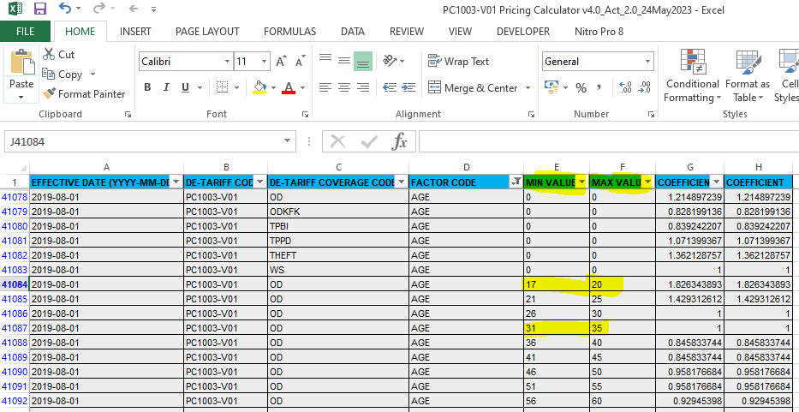

* The Coefficient Values of the SUMMARY_Final_Intercept and SUMMARY_Final_SIPiecewise will be maintained in two separate Tables.
* The Co-Efficient value of each pricing Factors mentioned in the SUMMARY_Final_Factor will be maintained in the Rules and Rating Engine in a separate Table for all the applicable Pricing Factors
* The Co-Efficient value of each Interactive Factors mentioned in the SUMMARY_Final_Interaction will be maintained in the Rules and Rating Engine in a separate Table for all the applicable Interactive Factors.
  + Insured Age and Gender
  + Insured Age and Vehicle Age
  + Insured Age Model and Vehicle Age

#### Tariff Capping

* Capping % shall be applied on the Tariff Contribution.
* Two Types for capping % is applicable.
  + Upper Cap%
  + Lower Cap%
* Upper Cap % and Lower Cap % shall be maintained in the Rules and Rating Engine
* Standard Capping %, which is applicable for all Source Type and Vehicle Type is as below.
  + Upper Cap 15%
  + Lower Cap 10%
* Special Capping % can be applied based on any one of the Pricing Factor or combination of the multiple Pricing factors as per the example below.
  + Single Pricing Factor - Vehicle Make - LEXUS – Lower Cap 100% and Upper Cap 120%
  + Multiple Pricing Factors – Make Toyota, Model Hilux and Vehicle Age above 15 - Lower Cap 100% and Upper Cap 130%
* Hence Standard and Special Capping shall be maintained in the N-Dimension Table.
* The Upper Cap and Lower cap shall be calculated based on the Tariff Contribution.
* The De-tariff Contribution shall be with in the Upper Cap and Lower cap.
* One Upper Capping and Lower Capping shall be the Default. In addition to default capping additional capping can be defined with selected factors. During Transaction for the selected factors when capping is not applicable, the default capping will be applied

#### Tariff Loading

* The Loading is applicable for Tariff Contribution and the same shall maintained in the Rules and Rating Engine
* Each Vehicle Type is having different Loading %
* Based on Agent Rules Group, the Loading % will be maintained
* Each Vehicle Type will have separate Maximum Cumulative Loading %
* When the Sum of the individual loading (example, Insured Age Loading, Vehicle Age Loading, Claims Loading) exceeds the Maximum Cumulative loading, the system shall apply the Maximum Cumulative loading.
* Loading % can be different, based on any one of the Pricing Factor or combination of the multiple Pricing factors as per the example below.
  + One Pricing Factor – Make - LEXUS – Loading 10% or Vehicle Age above 15 – Loading 15 %
  + Multiple Pricing Factors – Make Toyota, Model Hilux and Vehicle Age above 15 - Loading 20%
* Hence Loading shall be maintained in the N-Dimension Table. Refer Section 1.2.8.c
* Refer the attached Excel File for Tariff Loading

##### Maximum Cumulative Loading

* The Maximum Cumulative Loading applicable for each Vehicle Type shall be maintain in the   
  Rules and Rating Engine
* Refer the attached Excel File for Maximum Cumulative Tariff Loading

#### NCD

* The NCD % will be received as one of the Pricing Factor and the same will be used to compute the Tariff Contribution and De-Tariff Contribution.
* No NCD% Setup / maintenance will be available in the Rules and Rating Engine

#### Extra Coverage Rate and Formulas

* Extra Coverage Contribution shall also be calculated in the Rules and Rating Engine for both Tariff Products and De-Tariff Products Refer Section 1.2.1.b
* For the Extra Coverages received from the front end system, Rules and Rating Engine shall compute the Extra Coverage Contribution.
* Extra Coverages Rate and Contribution Calculation formula shall also maintained in the Rules and Rating Engine
* Refer the attached Extra Coverage Formulas and Rate. Sheet Name: AdditlBenTagtoSubClass and FormulaType

Note: The Rules and Rating Engine shall have the option to upload all the Rating Data

#### Commission, Discount and Wakalah Fees

##### Agent Wakalah Fee Commission

* Agent Wakalah Fee Commission is applicable for all Motor Vehicle Types and the same shall be maintained in the Rules and Rating Engine.
* Same Commission % is applicable for all Agents and this can configured.
* Refer the attached Commission Table

##### Rebate on Commission

* Rebate on Commission is a Rebate allowed by Agent to Customer, from the Agent’s Commission.
* Rebate on Commission % shall not exceed the Agent Commission % allowed for the respective class.
* Example, Agent Commission on Private Car is 10%. From this Commission 10%, Agent can pass some % to Customer as Rebate, example 5% or 6%. But the Rebate % cannot exceed the Agent Commission 10%
* Service Tax shall be calculated after applying the Rebate allowed to Customer.
* Rebate on Commission shall be passed from the Front End System. If the Rebate on Commission is more than the Commission%, the Rules and Rating engine shall raise an exception error message and shall not return the Contribution.

|  |  |  |
| --- | --- | --- |
| **CLASS_CODE** | **CLASS_NAME** | **CLASS_BROK_COMM** |
| MT | MOTOR | 10 |

##### Direct Discount (Allowed for Direct Walk in Customer)

* Direct Discount (Allowed for Direct Walk in Customer) is a discount allowed to a Customer who directly buy a Cover Note from the Insurer
* Maximum allowed Direct Discount % will be the same as Agent Commission % for the respective Class.
* In the Request Service, when Direct Discount indicator is received, the Rules and Rating engine will apply the Direct Discount and will not apply the Commission.
* Commission % maintained in the Rules and Rating Engine will be referred for Direct Discount also.

##### Discount other than Rebate on Commission and Direct Discount

* Apart from Rebate on Commission and Direct Discount, no other discount is applicable for a Customer.

##### Wakalah Fee Management Expenses

* Wakalah Fee Management Expenses % shall be maintained in the Rules and Rating Engine.
* Wakalah Fee Management Expenses % can be applied based on any one of the Pricing Factor or combination of the multiple Pricing factors.
* Wakalah Fee Management Expenses can be based on the sum covered, vehicle age, Insured Age, Capacity etc.,
* Wakalah Fee Management Expenses and Wakalah Fee Commission shall be maintained the same Table in two different columns

#### Service Tax

##### Service Tax on Tariff Contribution

* Service Tax % (6%) is applicable for Tariff Contribution and the same shall be maintained in a separate Table in Rules and Rating Engine.
* To arrive the Tariff Contribution this Service Tax % shall be applied.

##### Service Tax on De-Tariff Contribution

* Service Tax % (6%) is applicable for De-Tariff Contribution shall be maintained in a separate Table in the Rules and Rating Engine,
* This Service Tax table shall have effective from and Effective To Date
* Cover Notes Issue date shall be checked with Effective date of the Service Tax Setup

#### Stamp Duty

##### Stamp Duty for Tariff Contribution

* Stamp Duty (RM 10) is applicable for Tariff Contribution and the same shall be maintained in a separate Table in Rules and Rating Engine.
* To arrive the Tariff Contribution this Stamp Duty shall be applied.

##### Stamp Duty for De-Tariff Contribution

* Stamp Duty (RM 10) is applicable for De-Tariff Contribution and the same shall be maintained in a separate Table in the Rules and Rating Engine,
* This Stamp Duty shall have effective from and Effective To Date
* Cover Notes Issue date shall be checked with Effective date of the Stamp Duty Setup

##### Stamp Duty Waiver

* As per the current Circular, Stamp Duty waiver is not applicable for any of the Motor Product.
* Refer the attached Stamp Duty waiver Circular

#### Minimum Contribution

* Minimum Contribution applicable for each Class and Sub-Class shall be maintained in the Rules and Rating Engine
* Minimum Premium is applicable for both Tariff Premium and De-Tariff Premium
* When the Tariff Gross Premium is less than minimum premium, the minimum premium will be considered as gross premium.
* When minimum premium is applied, upper capping and lower capping will be applied on the minimum premium and this will be checked with the GLM Premium.



### Pricing / Rule Serial Number

* Rules and Rating Engine shall maintain the Pricing Serial Number
* Pricing Serial Number shall have Versioning and also shall have an Effective From Date
* When the front end System send the request parameters to Rules and Rating Engine, the Rules and Rating Engine shall apply the Cover Note's Issue Date to fetch the applicable Serial Number and not the Inception date of the Cover Note
* Based on the Agent Code received in the Request Service, Rules and Rating Engine shall get the applicable Agent Pricing Group.
* Rules and Rating Engine shall compute the Contribution applicable for the selected Agent Pricing Group
* Pricing Serial number format can changed later, with Technical assistance.

#### Basic Contribution

Separate Pricing Serial Number is applicable for Base / Basic Contribution Calculation (except Extra Coverage). Based on the Vehicle Type, Agent Group Pricing Serial Number will be auto generated



Data applicable for the GLM sheet shall be maintained in the above Table - Basic Contribution

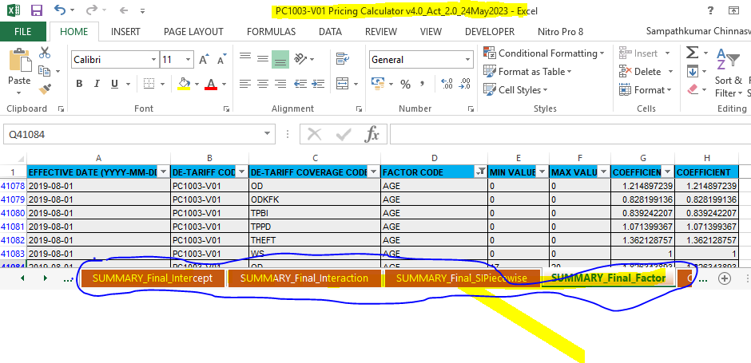

**Agree Value Clause:**

* Criteria for Agreed Value Clause shall be maintained in the Rules and Rating Engine.
* The User can add the Conditions for Agreed Value Clause in future.
* User can additional Criteria (similar to Vehicle Age, Usage) in future.
* Criteria Agreed Value Clause (AVC) will be maintained in against the Basic Contribution Pricing Serial Number. (While issue a Quotation if AVC is applied while convert the Quotation as Cover Note also AVC to be applied on the Cover Note. Only if we follow the Pricing Serial Number we can apply the AVC during Cover Note Issuance)



#### Extra Coverage Contribution

Since different Agent Group is having different Extra Coverages, separate Pricing Serial Number is applicable for Extra Coverage Setup. Based on the Vehicle Type, Agent Group Pricing Serial Number will be generated



Data applicable for the Extra Coverages shall be maintained in the above Table – Extra Coverage Contribution

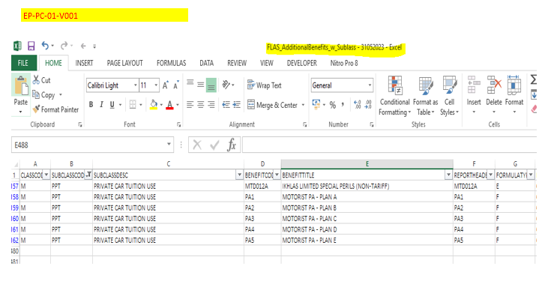

The Extra Coverages applicable for the specific Agent Group (franchise) shall be configured. These Extra Coverages shall not be available for other Agent Group (franchise). Example as below:

PTP +:

|  |  |
| --- | --- |
| **ENDT NO.** | **ENDORSEMENT TITLE** |
| MTD002A | Waiver of Compulsory Excess for Unnamed Driver – Private Car for Private Use |
| MTD003A | Flood Allowance at RM1,000 |
| MTD004A | Participant Personal Accident Cover |

TC MAKE:

|  |  |
| --- | --- |
| **ENDT NO.** | **ENDORSEMENT TITLE** |
| MTD002C | Waiver of Compulsory Excess for Unnamed Driver – Private Car for Private Use (Non-Tariff) |
| MTD003B | Flood Allowance at RM1,500 (Non-Tariff) |
| MTD004D | Personal Accident Coverage (Non-Tariff) |
| MTD008A | Car Replacement Allowance (Non-Tariff) |
| MTD009A | Window Snatch Theft (Non-Tariff) |
| MTD010A | Key Care Cover (Non-Tariff) |
| MTD011A | Additional Cash Payout (Non-Tariff) |

PIP:

|  |  |
| --- | --- |
| **ENDT NO.** | **ENDORSEMENT TITLE** |
| MTD002D | All Drivers – Proton  (Non-Tariff) |
| MTD003C | Flood Relief Allowance – Proton (Non-Tariff) |
| MTD004E | Personal Accident Coverage – Proton (Non-Tariff) |
| MTD010B | Key Care Cover – Proton (Non-Tariff) |

Below are the Extra Coverages applicable for Private Car Comprehensive Plus

|  |  |  |
| --- | --- | --- |
| **ENDT NO.** | **ENDORSEMENT TITLE** | **Remarks** |
| MTD002B | Waiver of Compulsory Excess for Unnamed Driver – Private Car for Private Use (Non-Tariff) | Contribution charge in Basic contribution |
| MTD004B | Complimentary Personal Accident Cover for Participant (Private Car for Private Use) (Non-Tariff) |
| MTD006A | Transportation Fee Reimbursement (Non-Tariff) |
| MTD007A | Waiver of Betterment (Non-Tariff) | Optional with additional contribution charge. |

#### Wakalah Fee Commission, Wakalah fee Management Expenses and Minimum Contribution

For Wakalah Fee Commission, Wakalah Fee Management Expenses and Min Contribution, Pricing Serial Number is common for all Vehicle Types across Motor.

Within the Pricing Serial Number for all Vehicle Types same Commission or for different vehicle Types different commission can be defined.

Within the Pricing Serial Number for all Vehicle Types same Min Contribution or for different vehicle Types different Min Contribution can be defined.

Based on the sum covered, vehicle age, etc., Wakalah fee can be maintained.



Sample data for Commission / Minimum Contribution Setup will be as below.



Note: Wakalah Fee Agent Commission % applicable for Motor shall be applied Motor Cross Selling Products MPA and Bantuan Ikhlas Supreme.

#### Tax / Duty

For Tax and Duty, Pricing Serial Number is common across TIGB. Within the Pricing Serial Number for different Classes different Rates can be defined, if required.

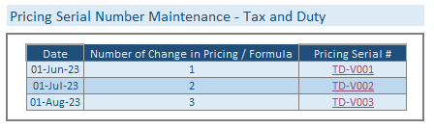

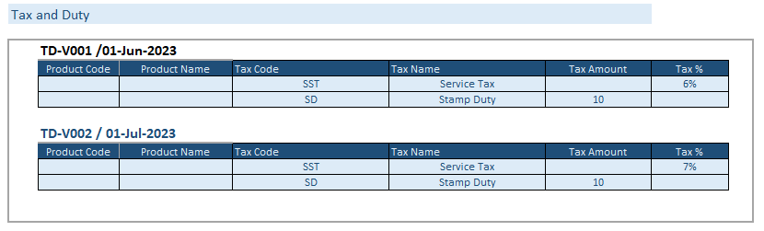

#### Rule Serial Number

* Since the Risk Criteria & Loading is based on the Agent Rule Group and the Pricing is based on the Agent Pricing Group, for Risk Criteria & Loading a separate Rule Serial Number shall be maintained in the Rules and Rating engine.
* Rule Serial Number shall have Versioning and also shall have an Effective From Date
* When the front end System send the request parameters to Rules and Rating Engine, the Rules and Rating Engine shall apply the Cover Note's Issue Date to fetch the applicable Rule Serial Number and not the Inception date of the Cover Note
* Based on the Agent Code received in the Request Service, Rules and Rating Engine shall get the applicable Agent Rule Group.
* Rules and Rating Engine shall get the Risk (Refer Risk / Decline Risk) and Loading % applicable for the selected Agent Rule Group.
* Maximum Cumulative Loading will also be maintained with in the Rule Serial Number.
* Refer the attached Excel file Agent Rules (For Risk Type and Loading)

For Risk Criteria and Loading, Rule Serial Number is common for all Vehicle Types across Motor. Within the Rule Serial Number for all Vehicle Types Risk Criteria and Loading can be defined.

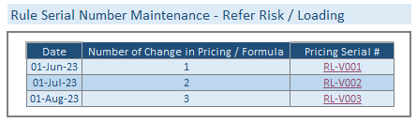

Sample Data:



Note: Additional Criteria can be added for Commission / Minimum Contribution setup and Risk Criteria / Loading Setup. Kindly confirm if any additional Criteria required

### Request and Response from Rules and Rating Engine

Request and Response xml will be updated in the Technical Document

### Contribution Calculation

#### Get the Rule Serial Number and Pricing Serial Number

Based on the Agent Code received in the Request Service, the system shall get the applicable Agent Rules Group and Agent Pricing Group. Based on the applicable group, the system shall get the applicable Rule Serial Number, Pricing Serial Numbers (for Basic Contribution, Extra Coverages, Commission/Discount and Taxes).

Based on the selected Rule and Pricing Serial Numbers, get the Rule Data and Pricing Data and compute the Contribution.

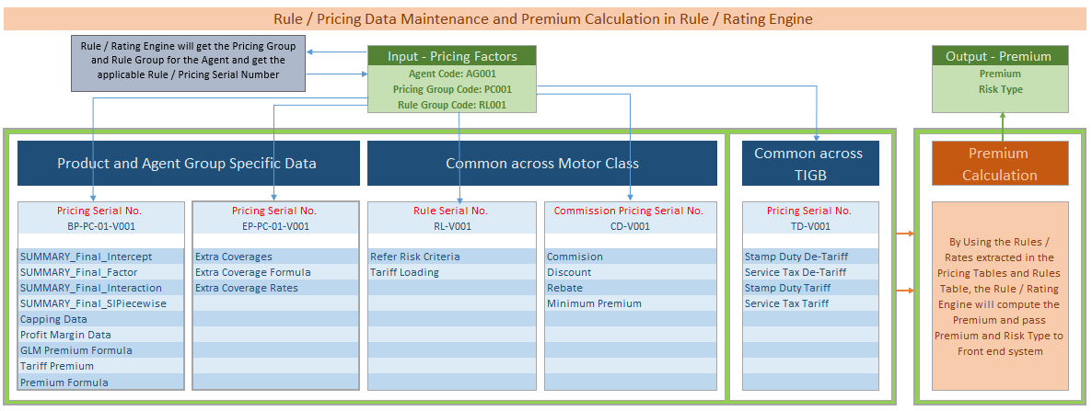

#### Steps to Compute the Contribution

Based on the Pricing Factors received from the front end system, the Rules and Rating Engine shall arrive the Contribution Chargeable by using the applicable Rule Serial No. and Pricing Serial No.



While Compute the Final Contribution chargeable to Customer, the system shall compute the Extra Coverage Contribution also as per the below section, as it is part of the Final Contribution chargeable to Customer.

#### Extra Coverage Contribution

* Extra Coverage Contribution shall also be calculated in the Rules and Rating Engine for both Tariff Contribution and De-Tariff Contribution
* For the Extra Coverages received from the front end system, Rules and Rating Engine shall compute the Extra Coverage Contribution.
* Refer the attached excel file for Extra Coverage Formulas
* PRIVATE HIRE CAR ENDORSEMENT (E-Hailing Endorsement) Contribution shall be calculated in the Rules and Rating Engine for Full Year and non-annual.

#### Rounding off

* While compute the Tariff Contribution, no Rounding off will be applied.
* After arriving the Tariff Contribution, while compute the Upper Capping and Lower Capping, the Rules and Rating Engine shall apply the 2 decimal Round off.
* While compute the GLM Contribution, no Rounding off will be applied at any step.
* Based on the Upper Capping, Lower Capping and GLM Contribution while arrive the final Contribution chargeable to Customer, the system shall apply the Round off to two decimal.

#### Motorist Personal Accident as Extra Coverage / Cross Selling Product

* For Motorist PA Extra Coverage, a separate Cover Note shall be generated. Hence for Motorist PA and Motor Cover Note, Service Tax and Stamp Duty shall be calculated separately
* Similar to Motorist PA, for Bantuan Ikhlas Supreme Extra Coverage, a separate Cover Note shall be generated. Hence for Bantuan Ikhlas Supreme and Motor Cover Note, Service Tax and Stamp Duty shall be calculated separately

#### Yearly Contribution from the Rules and Rating Engine

* The default Period of Cover for the Cover Note issued from the Front end System will be one Year.
* For the Pricing Factors received from the Front End System, Rules and Rating engine will always share the Yearly Contribution in the Response Service
* If the Period of Cover is not equal to 1 Year, the frontend system shall calculate the Contribution based on the Yearly Contribution received from the Rules and Rating Engine

#### Handling of the Level Contribution

* While compute the Contribution in the Rules and Rating Engine, the system calculate the following level Contribution.
  + Tariff Contribution
  + GLM Contribution
  + Final Contribution (Street Price)
* All the above level Contribution with its corresponding Contribution Components shall be sent from the Rules and Rating Engine to the Front End System which send the Request Service.
* The Front End System shall store the Level Contribution in their system and Integrate to TIGB.

#### Tariff Contribution for Electric Vehicles

* The Tariff Contribution for the Electric Vehicles shall be maintained in the Rules and Rating Engine
* Co-efficient value for the Electric Vehicle Capacity (KW) is not available in the current GLM Sheet provided by TIGB.
* For Electric Vehicles follow the Tariff Contribution and no tariff calculation is applicable.

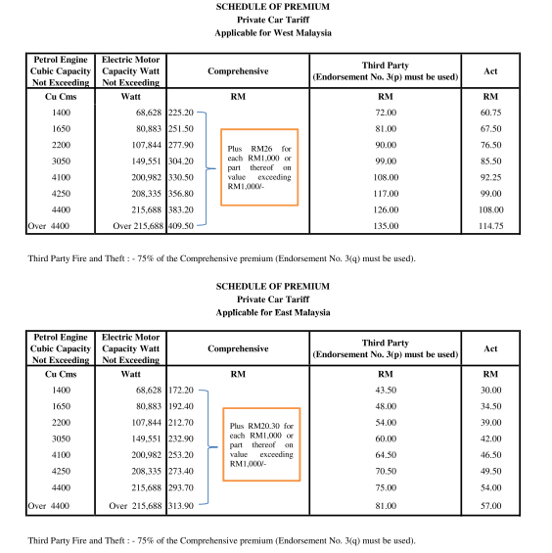

#### Excess

* While compute the contribution, the Rules and Rating Engine shall compute the Excess also and share the Excess value to the Front end system in the Response File.
* Refer the attached excel file Excess for Tariff Vehicle Types to compute Excess for the below Vehicle Types

1. MOBILE EQUIPMENT
2. BUS
3. TAXI
4. GOODS CARRYING VEHICLE

* Refer the attached excel file Excess for De-Tariff Vehicle Types to compute the Excess for the below Vehicle Types

1. PRIVATE CAR
2. MOTOR CYCLE

#### Tariff Contribution for Commercial Vehicles

* Tariff Premium shall be calculated for Commercial Vehicles asper the below attached documents. Sample Premium Calculation can be provided by TIGB for all Vehicle Types under Commercial Vehicles
* Refer the Attached Files for Tariff Premium Calculation for Commercial Vehicles

#### Sample Contribution Calculation – Minimum Premium

##### Tariff Sample Contribution– without minimum premium



##### Tariff Sample Contribution Calculation – with minimum premium



##### De-Tariff Sample Contribution– without minimum premium



##### De-Tariff Sample Contribution– with minimum premium



### Pricing Serial Number Transactions

#### Pricing Serial Number in Quotation

* When the Front End System issue a Quotation, when a Request received from the Front End System, in the Response Service, the Rules and Rating Engine will send the Rule Serial Number and Pricing Serial Number (Except Pricing Serial Number applicable for Service Tax and Stamp Duty) which was used to compute the Contribution. It will be combination of all applicable Pricing Serial Number and Rule Serial Number
* Example “BC-PC01-001-V01/EC-PC01-001-V01/CD-V001/RL-V001”
* The Front End System shall store this Rule Serial Number and Pricing Serial Number against the Quotation
* While edit the Quotation, when there is no change in the Factors which has an effect the Contribution, the front end system shall pass the Rule Serial Number and Pricing Serial Number which was saved against the Quotation. By using this Rule Serial Number and Pricing Serial Number the Rules and Rating Engine will compute the Contribution. Since we are using the same Rule Serial Number and pricing serial number at the time of Quotation issuance and edit, there will not be any difference in Contribution before Service Tax and Stamp Duty
* While Edit the Quotation the system shall apply the Service Tax and Stamp Duty applicable on the Quotation Edit Date. i.e., Service Tax and Stamp Duty applicable on the current date will be charged. If there is any change in the Service Tax and Stamp Duty between Quotation Issue date and Quotation edit date, the Premium Payable by Customer will change accordingly.
* While edit the Quotation, when there is any change in the Factors which has an effect the Contribution, the front end system not pass the Rule Serial Number and Pricing Serial Number which was saved against the Quotation. Since the Pricing Factors are changed, the Rules and Rating Engine will apply the new Rule Serial Number and Pricing Serial Number which is effective at that time. The new Contribution may be different with the old one as the pricing factors are changed.

#### Pricing Serial Number while Convert a Quotation as Cover Note

* When the Front End System issue a Quotation, when a Request received from the Front End System, in the Response Service, the Rules and Rating Engine will send the Pricing Serial Number (Except Pricing Serial Number applicable for Service Tax and Stamp Duty) which was used to compute the Contribution.
* The Front End System shall store the Pricing Serial Number against the Quotation
* While Convert the Quotation as Covernote, when there is no change in the Factors which has an effect the Contribution, the front end system shall pass the Pricing Serial Number which was saved against the Quotation. By using this Pricing Serial Number the Rules and Rating Engine will compute the Contribution. Since we are using the same pricing serial number at the time of Quotation issuance and Converted as Cover Note, there will not be any difference in Contribution.
* While Convert the Quotation as Cover Note, the system shall apply the Service Tax and Stamp Duty applicable on the Quotation Edit Date. i.e., Service Tax and Stamp Duty applicable on the current date will be charged. If there is any change in the Service Tax and Stamp Duty between Quotation Issue date and Quotation edit date, the Premium Payable by Customer will change accordingly.
* While convert the Quotation as Cover Note, when there is any change in the Factors which has an effect the Contribution, the front end system not pass the Pricing Serial Number which was saved against the Quotation. Since the Pricing Factors are changed, the Rules and Rating Engine will apply the new Pricing Serial Number which is effective at that time. The Cover Note Contribution may be different with the Quotation Contribution as the pricing factors are changed.

#### Pricing Serial Number for Cover Note

* When the Front End System issue a Cover Note with Quotation or without Quotation, when a Request received from the Front End System, in the Response Service, the Rules and Rating Engine will send the Pricing Serial Number which was used to compute the Contribution. The Front End System shall store the Pricing Serial Number against the Cover Note.

#### Endorsement to Cover Note

* While the Front End System issue a Motor endorsement, with the revised pricing factors the front end system shall pass the Pricing Serial Number which was saved against the Cover Note. By using this Pricing Serial Number, for the revised pricing factors, the Rules and Rating Engine will compute the Contribution and pass the new Contribution to the front end system.
* By using the new Contribution the front end shall compute the endorsement Contribution

Note: For all Transactions, Quotation / New Business / Renewal / Endorsement, while compute the contribution, the Rules and Rating Engine will apply the Service Tax and Stamp Duty applicable on the transaction (Issue) date. i.e., Service Tax and Stamp Duty applicable on the current date will be charged.

### Storage in the Rules and Rating Engine

* Only the Pricing related data like Factors, Co-Efficient Value, only will be stored in the Rules and Rating Engine
* Cover Note / Policy level Contribution will not be stored in the Rules and Rating Engine
* The Front end System Cover which send the Request to Rules and Rating Engine shall store all the required Contribution details for TIGB’s future Reference

### Audit Log

* The Rules and Rating Engine shall maintain the log details, User, Date and Time for Audit purpose

### Rules and Rating Engine Sample Screens

The below are the sample Screens to enter the pricing data for the various pricing factors

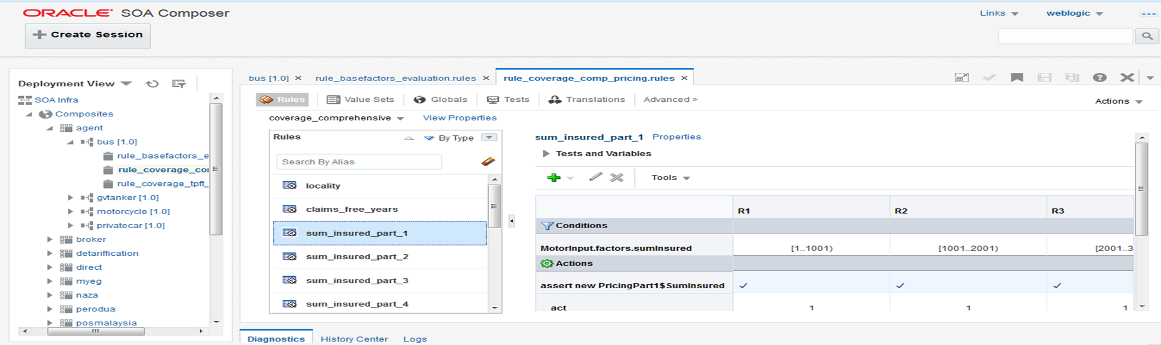

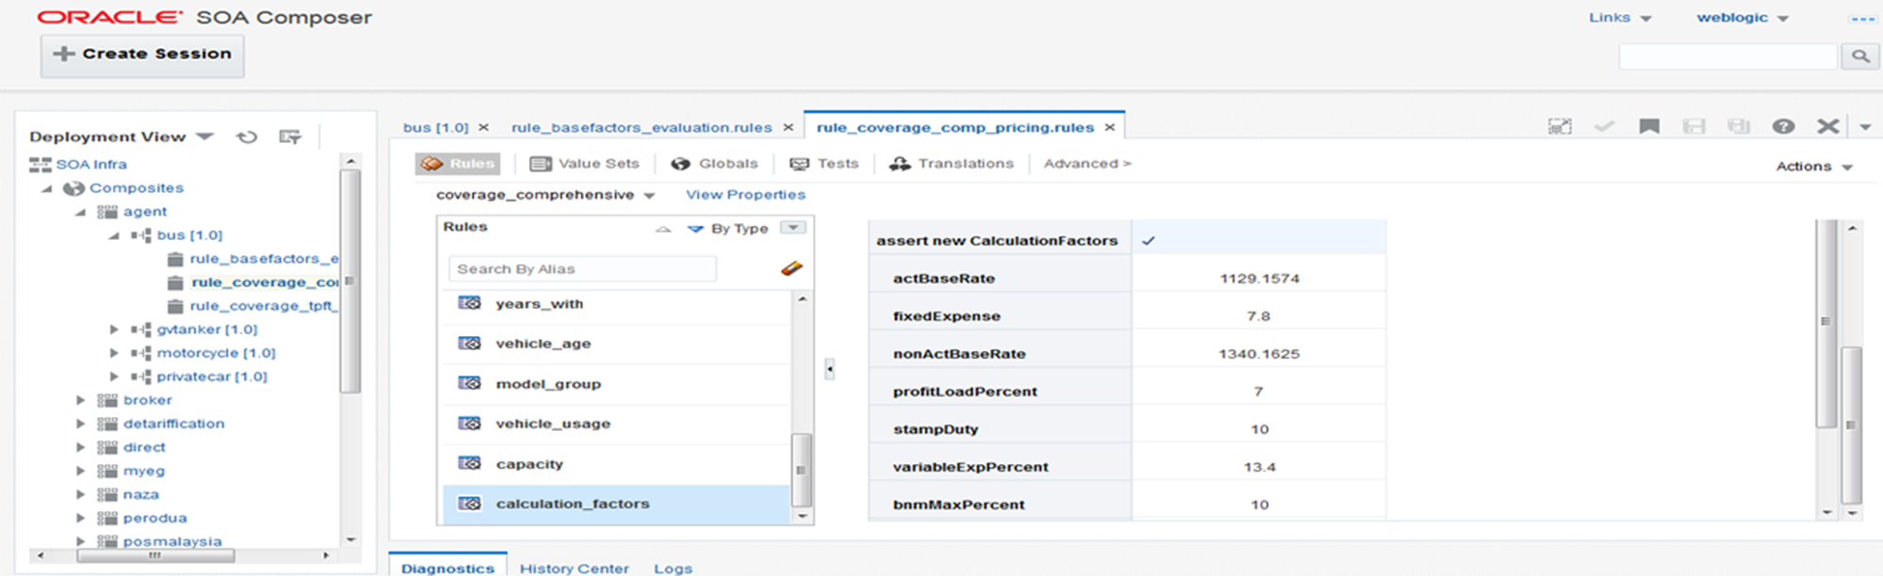

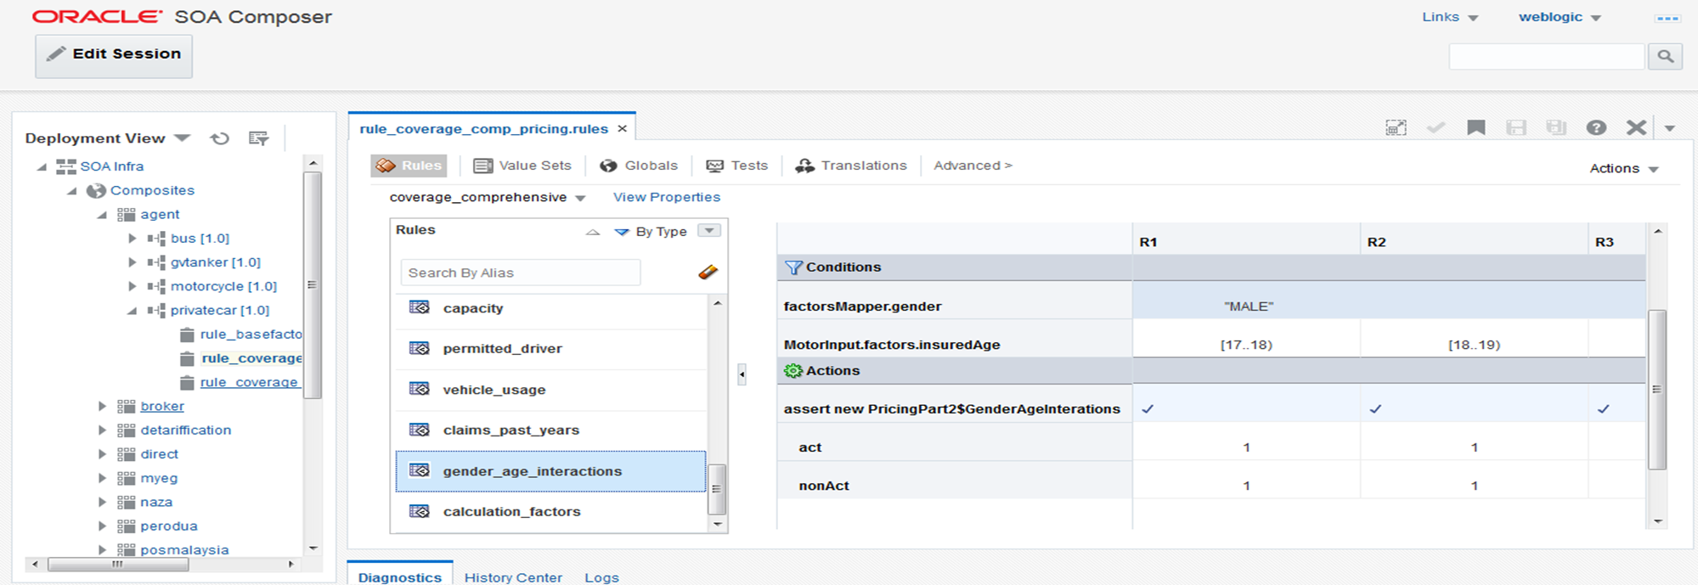

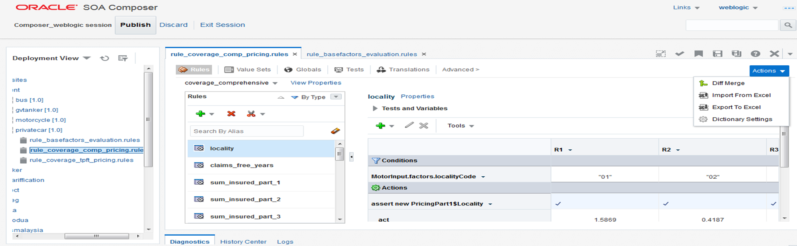

### Functions available in Rules and Rating Engine.

This section is applicable for all LOBs.

Below are the functions that will be covered under the scope of Rules and Rating Engine,

1. Efficient Handling of Large Datasets and Versatile Data Format Support,
   * This facility can handle large datasets of relativities quickly and efficiently. It can process 100,000 rows of data in less than 30 minutes.
   * The facility accepts data in a variety of formats, including XLS, XLSX and XLSM.
   * The setup process is simple and straightforward. The facility can be up and running in minutes.
2. Flexibility in Rating Table Scheduling:
   * The system offers the capability to schedule the start and end dates for Rating Tables.
   * Users have the ability to define and set specific commencement and expiry dates for Rating Tables according to their requirements.
3. Customizable based on Rating Tables: The system provides the flexibility to tag Rating Tables based on specific criteria such as agent codes, channels, locations, vehicle makes, and more.
4. Capable of designing the layout of a rating table, such as whether to include all rating factors, their respective parameter levels, and loss type in one table or separate tables.
5. Standard rating factor definition e.g., introduction of rating factors and interacting factors, setting of parameter levels, format of rating factor (categorical/numerical)
6. Engine can evaluate both stepwise and formula-based relativities, as well as loss types.
7. The system facilitates easy navigation of uploaded relativities through efficient filtration options, including date, approval status, user, rating factor, and more.
8. To address erroneous or missing relativity uploads, the system implements safety nets such as assigning a default relativity of 1.00 for new vehicle models not found in the existing Rating Table.
9. The system offers the capability to classify vehicle models into distinct groups, such as sedan, small, MPV, etc., for efficient vehicle model grouping.
10. The system includes a feature to highlight newly quoted premium for vehicle models that are not yet specified in the Rating Engine, enabling users to identify gaps and take necessary actions to address them effectively.
11. The system allows flexible capping/cupping function that can be applied to Tariff rates.
12. The system enables users to adjust the commission (%) and Wakalah Fee Management Expenses (%) based on factors such as product, subclass, channel, and more, offering flexible customization options.
13. The deployment process from UAT to LIVE is seamless, eliminating the need for an additional round of Rating Table upload and maintenance on the LIVE environment.
14. The system offers an API integration capability to establish connections with various systems, including backend, ISM, JPJ, and others.
15. The endorsement premium calculations can be computed annually by referencing previous versions of the Rating Table to ensure proper calculation adjustments.
16. Adding additional benefits is made easy, incorporating pre-fixed rating, formula-based rating, and other relevant features to provide flexibility and customization options.
17. The system offers a detailed breakdown of premiums at a granular level, providing comprehensive visibility into premium components.
18. A web-based calculator interface is available for stakeholders to efficiently compute premiums based on the uploaded Rating Tables, enabling convenient validation of premium calculations.
19. Governance,
    * User access control i.e., accessibility, number of ID, etc.
    * Proper date and version control of Rating Tables
    * Availability of process workflow - to assign tasks for specific users, approval from managers, next steps, etc. from UAT to LIVE deployment. To include notification/escalation to ensure tasks are performed in a timely manner
    * Availability of audit trail - storing of timestamp, user, area of rating engine, activities performed/changes in the rating engine. User is able to download the logs.
20. Error Handling and Error messages

### Business process Flow

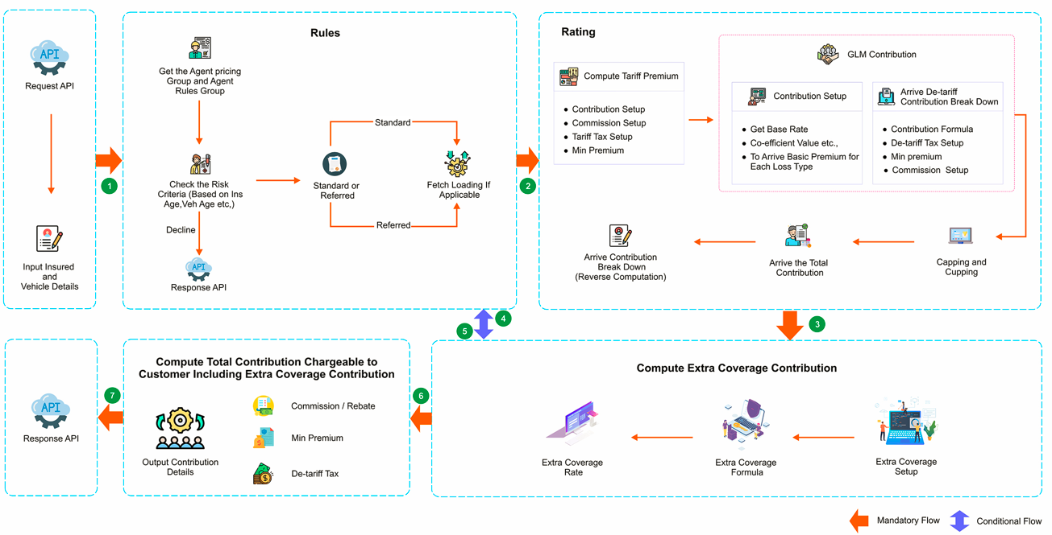

## Definition of Terminologies Used

| **Term** | **Definition** |
| --- | --- |
| BRD | Business Requirement Document |

# Appendix

|  |  |  |  |
| --- | --- | --- | --- |
| **S No.** | **Description** | **File Name** | **Attachment** |
|  | BRD | To be updated |  |
|  | Sample GLM Workbook – Private Car | PC1003-V01 Pricing Calculator v4.0_Act_2.0_24May2023 |  |
|  | Sample GLM Workbook – Private Car | MC1004-V01 Pricing Calculator v4.0_Act |  |
|  | Master List of Extra Coverages, Extra Coverage Formulas and Rate | FLAS_AdditionalBenefits_w_Sublass – 31052023 |  |
|  | Agent Commission Percentage | Min Contribution & Comm ver1.6 (Circular Commission) - 29 May 2023 |  |
|  | Stamp Duty waiver Circular | OC-GUW 008_09_2022_General Underwriting_waiver Stamp Duty_ v02 |  |
|  | Agent Rules – (Risk Type and Tariff Loading %) | FLAS PRODUCTION RUW SET-UP (ALL UWSET GROUP) FOR PC & MC (EXTRACTED AS AT 5-5-2023) |  |
|  | Pricing Serial Number generation | Motor_Pricing Serial Number_12Jun2023 |  |
|  | Motor Vehicle Type Master | VehTypeCode |  |
|  | Agent – Agent Rules Group Mapping | Agent tag RUW Code - Item 22 |  |
|  | Agent – Agent Pricing Group Mapping | TIG Agent tag Pricing Code - Item 21 B to provide |  |
|  | Make, Model and Segment Setup | Make Model List_12Jun2023 |  |
|  | Excess for Tariff Vehicle Types | Excess (Tariff Sub classes - ALL UWSET Group) |  |
|  | Excess for De-Tariff Vehicle Types | FLAS PRODUCTION RUW SET-UP (NL MAINTENANCE) FOR PC & MC (EXTRACTED AS AT 2-5-2023)_14Jun_Excess |  |
|  | Tariff Premium Calculation for Commercial Vehicles | Tariff Computation |  |
|  | Loading Types for Primary Loading and Secondary Loading | Clarifications on RUW Loading-Setting - Item 5(1) |  |
|  | Maximum Cumulative Tariff Loading | BNM Maximum Cummulative Loading |  |